FOR ONLINE BOOKING PLEASE VISIT <https://erda.membermeister.com/register>

Alternatively please print/save this to your computer and return to [erdarutland@gmail.com](mailto:erdarutland@gmail.com)

In ‘Additional Notes’ please write which classes you are interested in attending for a trial.

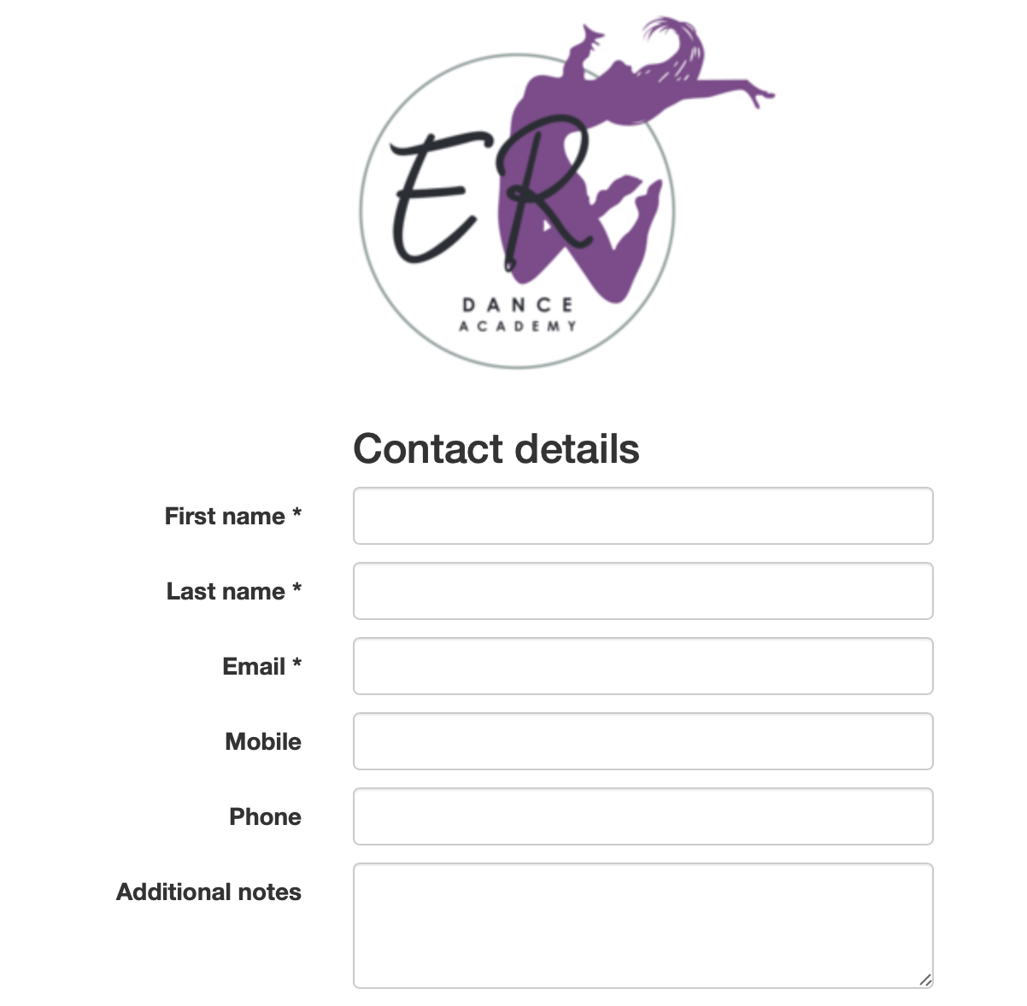

PLEASE RETURN THIS FORM VIA EMAIL TO ERDARUTLAND@GMAIL.COM